Student Name | G. Manasa
Student Registration Number | 241U1R3007 | Class &Section: CSE(DS)
Study Level: UG/PG | UG | Year &Term: I & II
Subject Name | Probability & Statistics

Name of the Assessment | Reflective Journal -9
Date of Submission | 06/09/2025

Reflective Journal Template
Journal Entry Guidelines | Description
1. Experience (Class Content) | Briefly describe the topics or concepts discussed during the class.
2. Feelings (Emotional Reactions) | Share your emotional reactions and thoughts during the class.  How did you feel while learning this theory?  Did the class evoke specific emotions or questions?
3. Learning (Key Insights) | Reflect on what you learned from the class.  Highlight the key insights or fundamental concepts you gained from the class.
4. Application (Practical Use) | Describe how you plan to apply the theory you've learned in real-life situations or in your academic/career endeavours.  Explain the practical utility of this theory.

Sample Journal Entry

Date | 06-09-2025
Journal Entry Topic
1. Experience (Class Content) | In this module we learned about correlation. correlation is simply about finding the relationship between two variables. The number between -1 and +1 tells us how strong or weak the relationship is. If the change in one variable changes the other variable then there exists a correlation. Also there are two types of correlation they are:  - Positive correlation  - Negative correlation  If the two variables are moving in the same direction then the two variables are known as positively correlated.  If the two variables are deviated in the opposite direction then the two variables are known as negatively correlated.  Next we learned about zero correlation if there in no relation between two variables are uncorrelated variables. After that we discussed about scatter diagram next we learned about correlation coefficient if the measure of coefficient linear relationship between variables x & y called correlation and also it is developed by karlpearson.  $$r=\left(x,y\right)=\frac{cov(x,y)}{σx σy}$$  Where $cov\left(x,y\right)=\frac{1}{n}\sum_{i=1}^{n}{xi yi-\overline{x.\overline{y}}}$  At last we discussed about properties of correlation coefficient and next we discussed about partial correlation and multiple correlation.
2.Feelings (Emotional Reactions) | At first, I felt a bit confused and nervous when I heard about correlation. But after seeing examples, I became curious and slowly started to understand. While drawing the scatter diagram, I felt happy and confident because it was easy to see the relation. At first the formula looked hard, but after practice, I felt proud and confident.
3. Learning (Key Insights) | 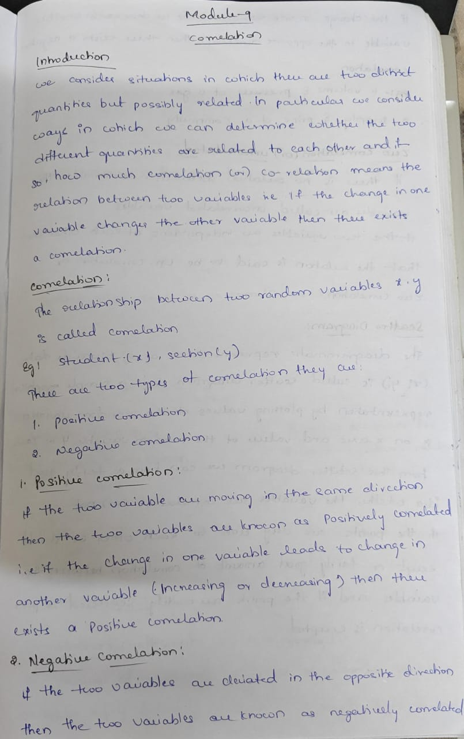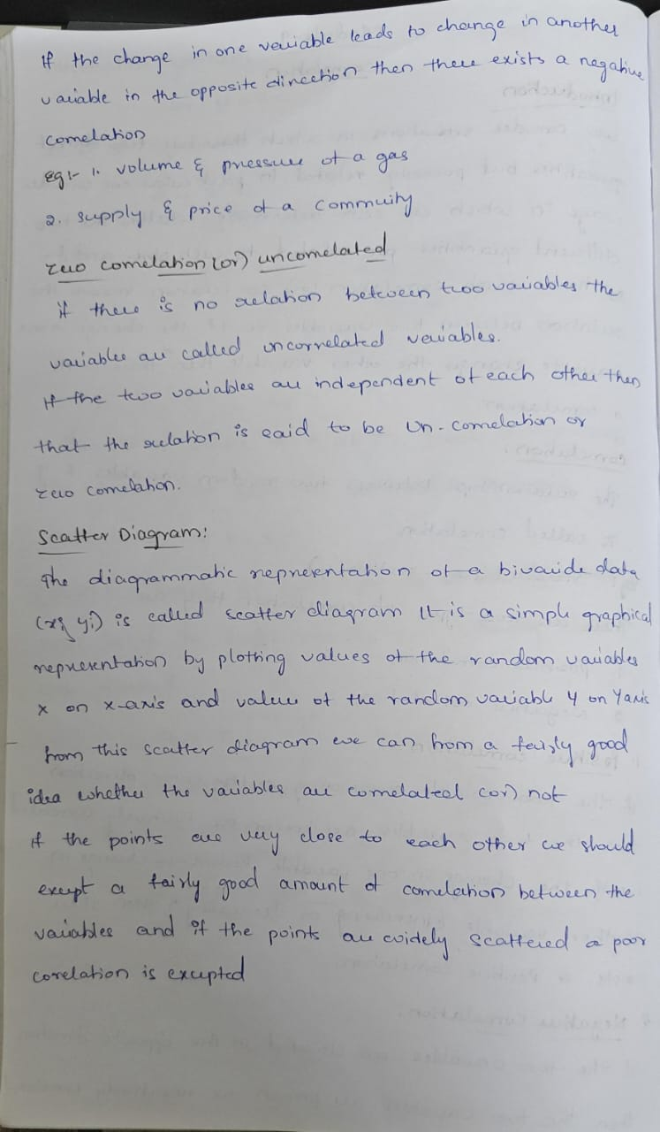  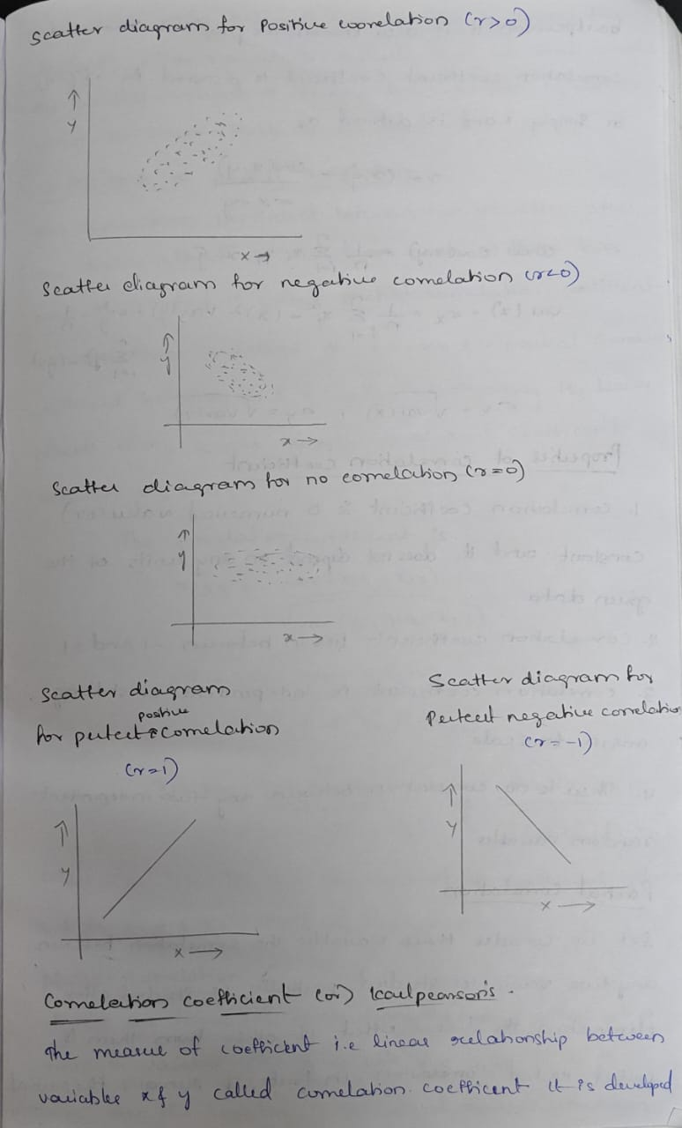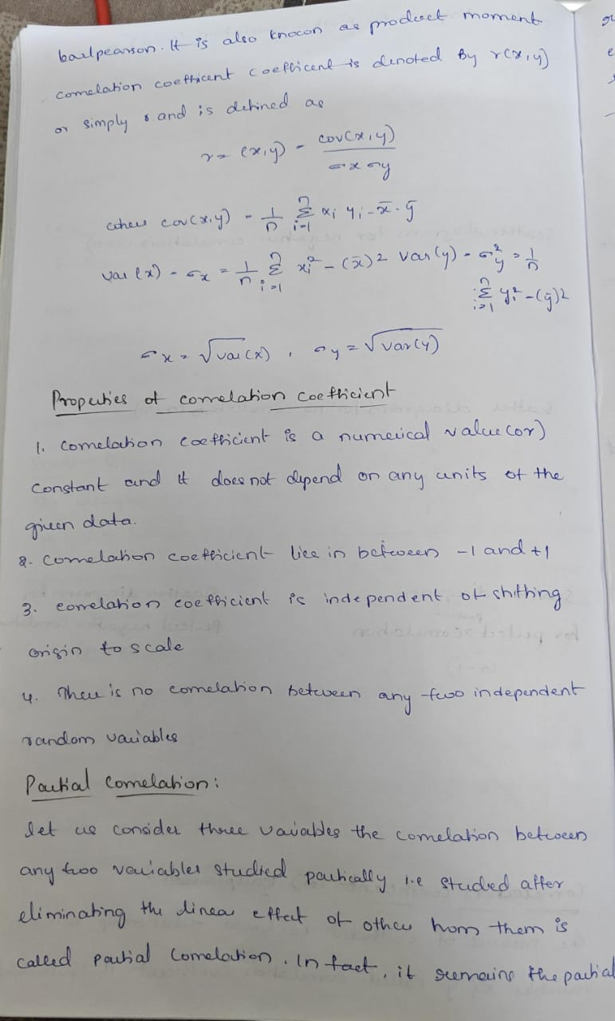  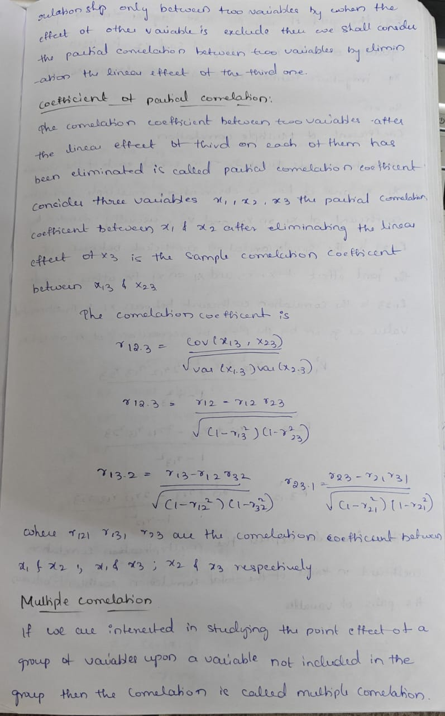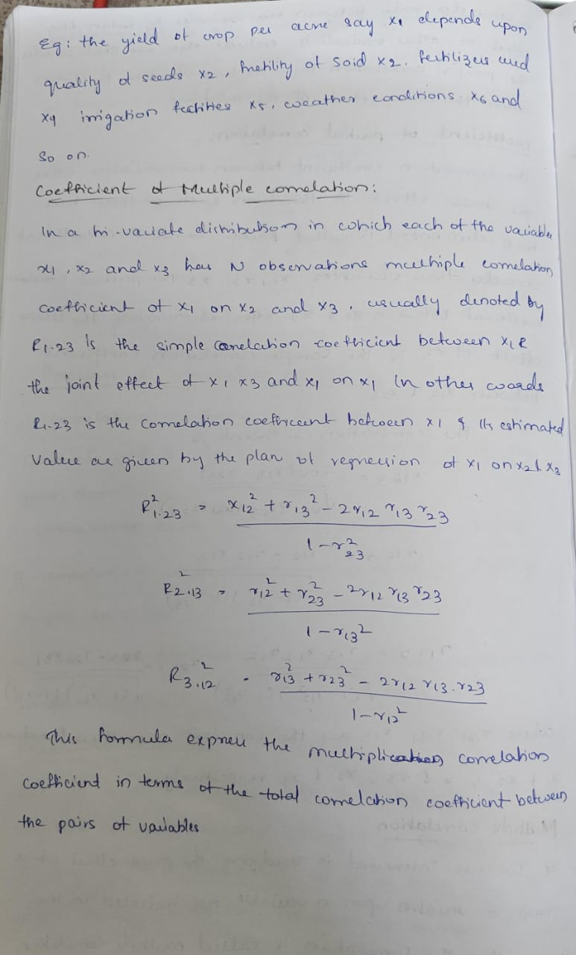  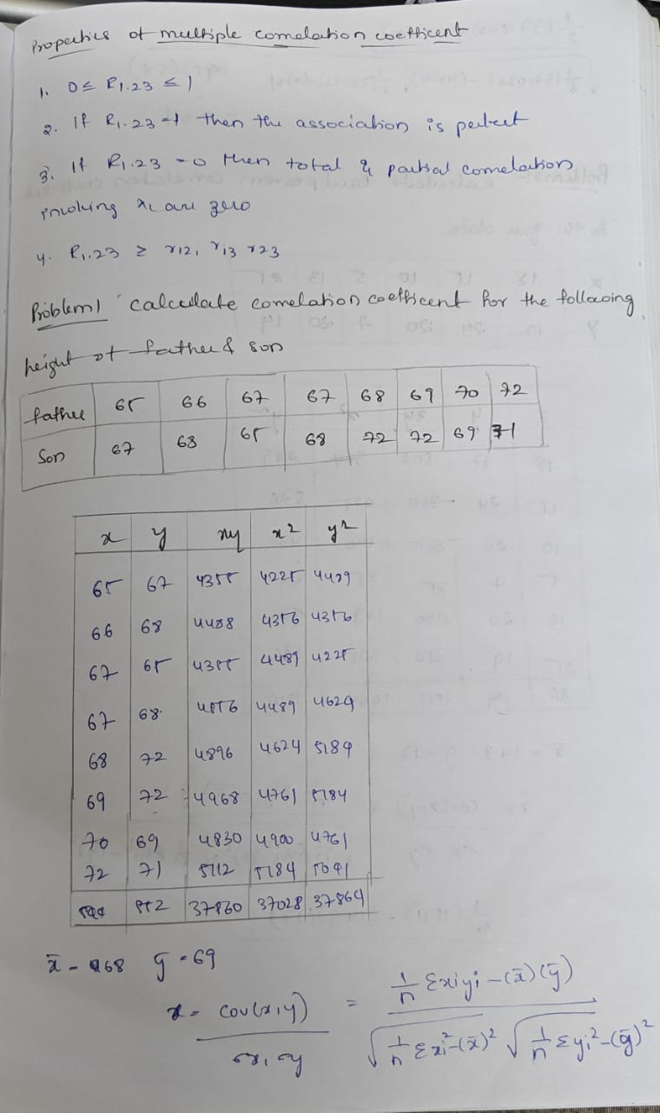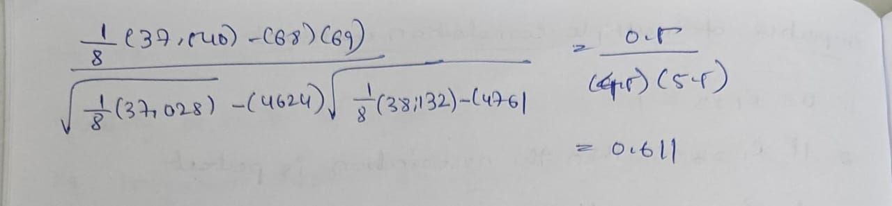
4. Application (Practical Use) | Correlation  Applications:  - In education, relation between study time and exam results.  - In business, relation between advertising and sales.  - In health, relation between exercise and body fitness.  - In economics, relation between income and expenditure.  Scatter Diagrams  Applications:  - Identifying Outliers: Unusual data points that deviate from the general pattern can be easily spotted.  - Forecasting: Projecting future sales based on historical advertising spend by observing patterns.  Correlation Coefficient  - Sign (+ or -): Indicates the direction of the relationship (same or opposite directions).  - Absolute Value: Represents the strength of the correlation; a value closer to 1 (or -1) indicates a stronger relationship.  Applications:  - Risk Management: In investment, the coefficient helps determine if adding an asset to a portfolio will improve diversification and reduce volatility.  - Data Analysis: Providing a precise numerical measure of the relationship's strength that a scatter diagram alone cannot.  Correlation Analysis  Applications:  - Business & Commerce: Examining the link between budget allocations and revenue or working capital and profitability.  - Market Trends: Analyzing the relationship between market conditions (like consumer confidence) and company performance to inform decision-making.  - Performance Evaluation: Assessing the effectiveness of training programs by correlating training hours with employee performance scores.  - Economic Understanding: Identifying key variables that influence others and understanding how economic disturbances spread.  - Scientific Research: Studying naturally occurring variables that cannot be manipulated in experiments, such as the relationship between education and crime rates.
Conclusion | I understood that correlation tells us how two things are related. A scatter diagram helps us see the relation on a graph, and the correlation coefficient gives the exact value of the relation. At first I felt confused but after practice I felt confident and happy because I could connect maths with real-life examples like study hours and marks or income and spending. This topic taught me that statistics is not only numbers but also a way to understand real-life situations better.

